Assignment -3

Bucket And Watson assistant

|  |  |
| --- | --- |
| Assignment Date | 7 October 2022 |
| Team lead | Karthick.S |
| Student Roll Number | 721719104303 |
| Maximum Marks | 2 Marks |

Questions:

1. Create a Bucket in IBM object storage.

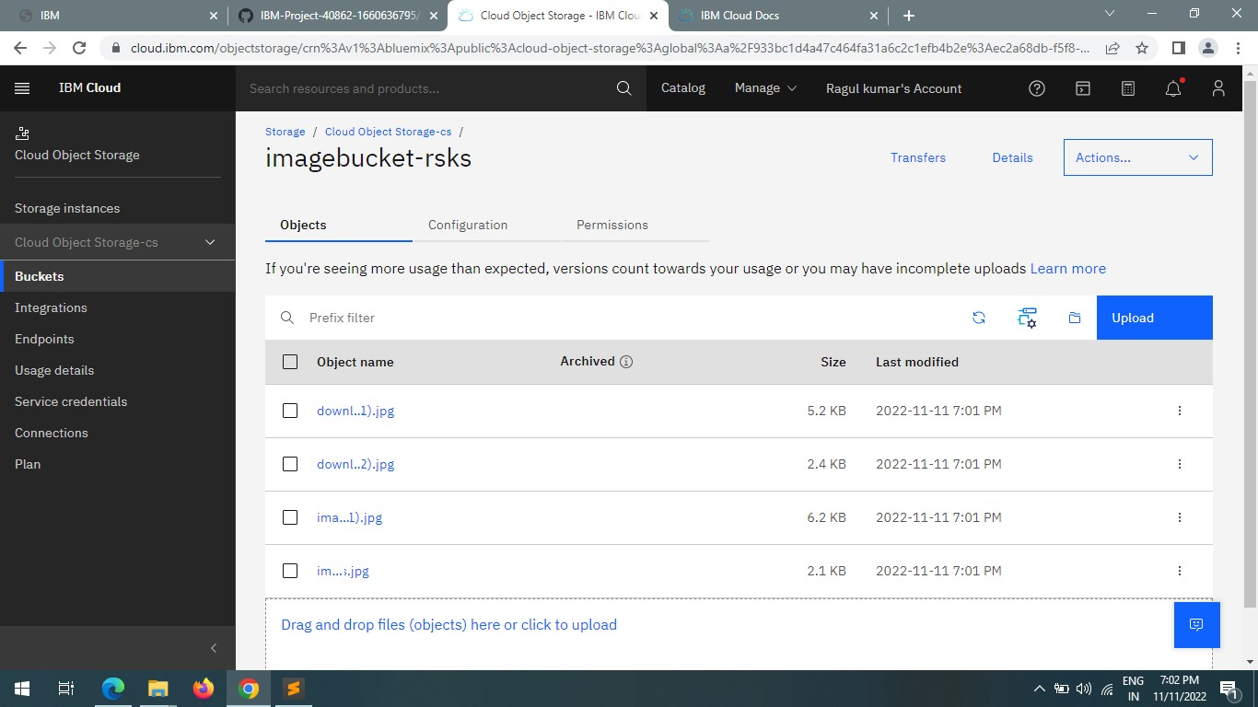

1. Upload an 5 images to ibm object storage and make it public. write html code to displaying all the 5 images.

Index.html

<!DOCTYPE html>

<html lang="en">

<head>

<meta charset="UTF-8">

<meta http-equiv="X-UA-Compatible" content="IE=edge">

<meta name="viewport" content="width=device-width, initial-scale=1.0">

<title>Smart Fashion shop </title>

<link rel="stylesheet" href="style.css">

<style> body {

background-color: #ff8080; display: flex; align-items: center; justify-content: center; flex-direction: column;

}

img { height: 240px; border-radius: 10px; margin: 10px;

}

</style>

</head>

<body>

<h1>Wellcome To RSKS SHOPPING !!!</h1>

<div>

<img src="download.jpg" alt="Dress" srcset=""> <img src="download (1).jpg" alt="Dress" srcset=""> <img src="download (2).jpg" alt="Dress" srcset=""> <img src="images (1).jpg" alt="Dress" srcset=""> <img src="images.jpg" alt="Dress" srcset="">

</div>

<h1>Use the ChatBot for shopping -----> </h1>

<script>

window.watsonAssistantChatOptions = { integrationID: "e9659331-05e0-4549-8fa7-3e306f8aa52c", // The ID of this integration. region: "au-syd", // The region your integration is hosted in.

serviceInstanceID: "42e5c10d-4956-40ca-8f9d-23adb2409ddb", // The ID of your service instance.

onLoad: function(instance) { instance.render(); }

};

setTimeout(function(){

const t=document.createElement('script');

t.src="https://web-chat.global.assistant.watson.appdomain.cloud/versions/" +

(window.watsonAssistantChatOptions.clientVersion || 'latest') + "/WatsonAssistantChatEntry.js"; document.head.appendChild(t);

});

</script>

</body>

</html>

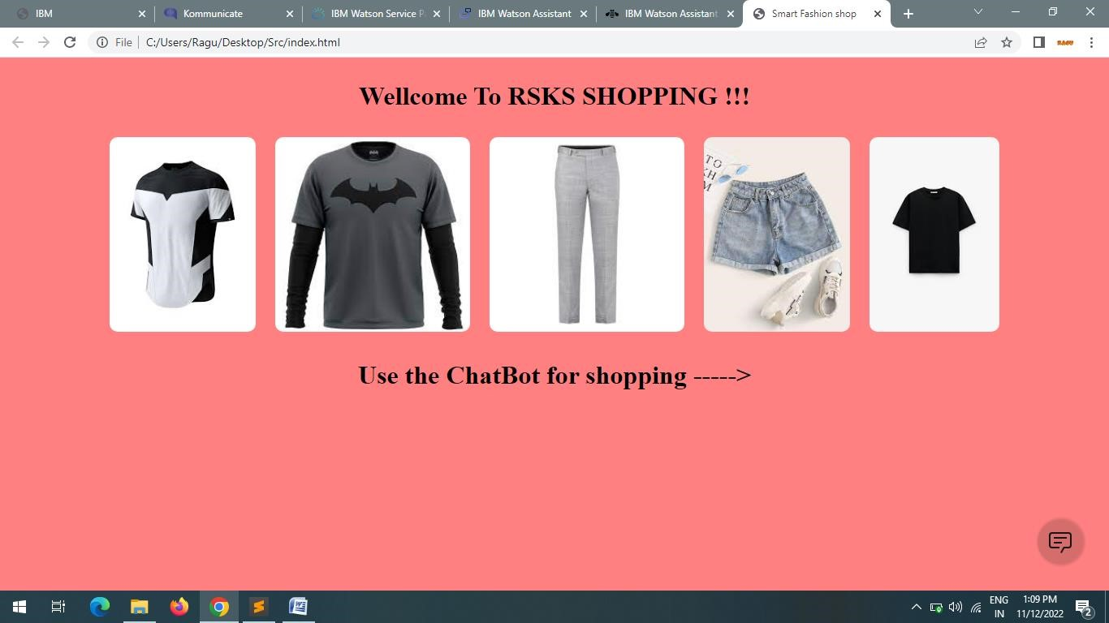

3. Upload a css page to the object storage and use the same page in your HTML code.

<!DOCTYPE html>

<html lang="en">

<head>

<meta charset="UTF-8">

<meta http-equiv="X-UA-Compatible" content="IE=edge">

<meta name="viewport" content="width=device-width, initial-scale=1.0">

<title>Smart Fashion shop </title>

<link rel="stylesheet" href="style.css">

</head>

<body>

<h1>Wellcome To RSKS SHOPPING !!!</h1>

<div>

<img src="download.jpg" alt="Dress" srcset=""> <img src="download (1).jpg" alt="Dress" srcset=""> <img src="download (2).jpg" alt="Dress" srcset=""> <img src="images (1).jpg" alt="Dress" srcset=""> <img src="images.jpg" alt="Dress" srcset="">

</div>

<h1>Use the ChatBot for shopping -----> </h1>

<script>

window.watsonAssistantChatOptions = { integrationID: "e9659331-05e0-4549-8fa7-3e306f8aa52c", // The ID of this integration. region: "au-syd", // The region your integration is hosted in.

serviceInstanceID: "42e5c10d-4956-40ca-8f9d-23adb2409ddb", // The ID of your service instance.

onLoad: function(instance) { instance.render(); }

};

setTimeout(function(){ const t=document.createElement('script');

t.src="https://web-chat.global.assistant.watson.appdomain.cloud/versions/" +

(window.watsonAssistantChatOptions.clientVersion || 'latest') + "/WatsonAssistantChatEntry.js"; document.head.appendChild(t);

});

</script>

</body>

</html>

</html>

Output:-

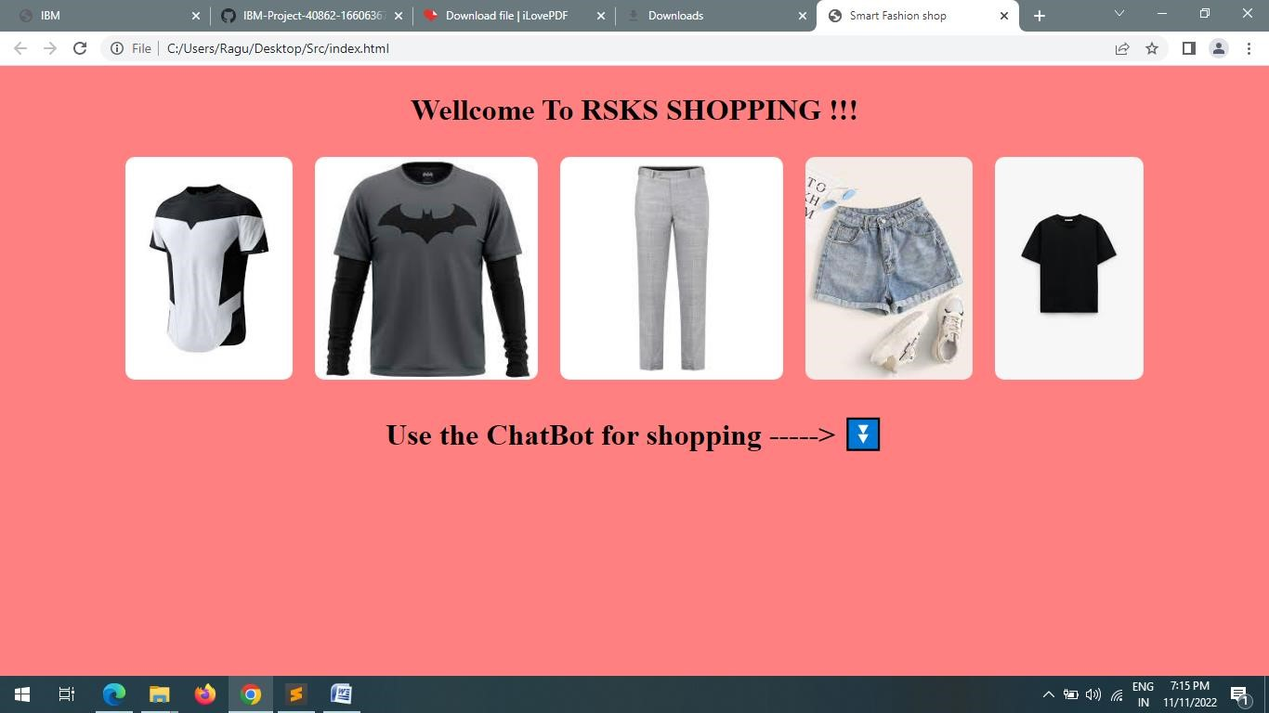

4. Design a chatbot using IBM Watson assistant for hospital. Ex: User comes with query to know the branches for that hospital in your city. Submit the web URL of that chat bot as a assignment.

Url :- [chatbot link](https://web-chat.global.assistant.watson.appdomain.cloud/preview.html?backgroundImageURL=https%3A%2F%2Feu-gb.assistant.watson.cloud.ibm.com%2Fpublic%2Fimages%2Fupx-2187bdc6-3463-4336-a0e5-105ac4d979db%3A%3A31897cd3-e620-4527-80d8-c93d7c618899&integrationID=fd3649a9-27f7-43a9-96c0-5ca4d5bbf885&region=eu-gb&serviceInstanceID=2187bdc6-3463-4336-a0e5-105ac4d979db) <- click

Image-

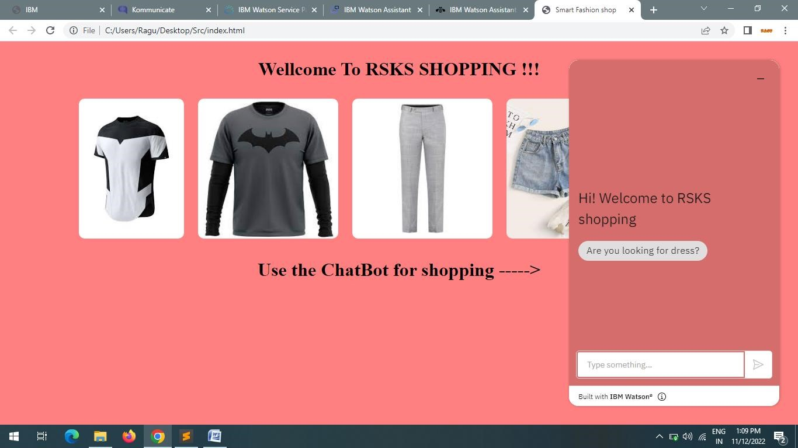

5 .Create Watson assistant service. Load that script in HTML page

